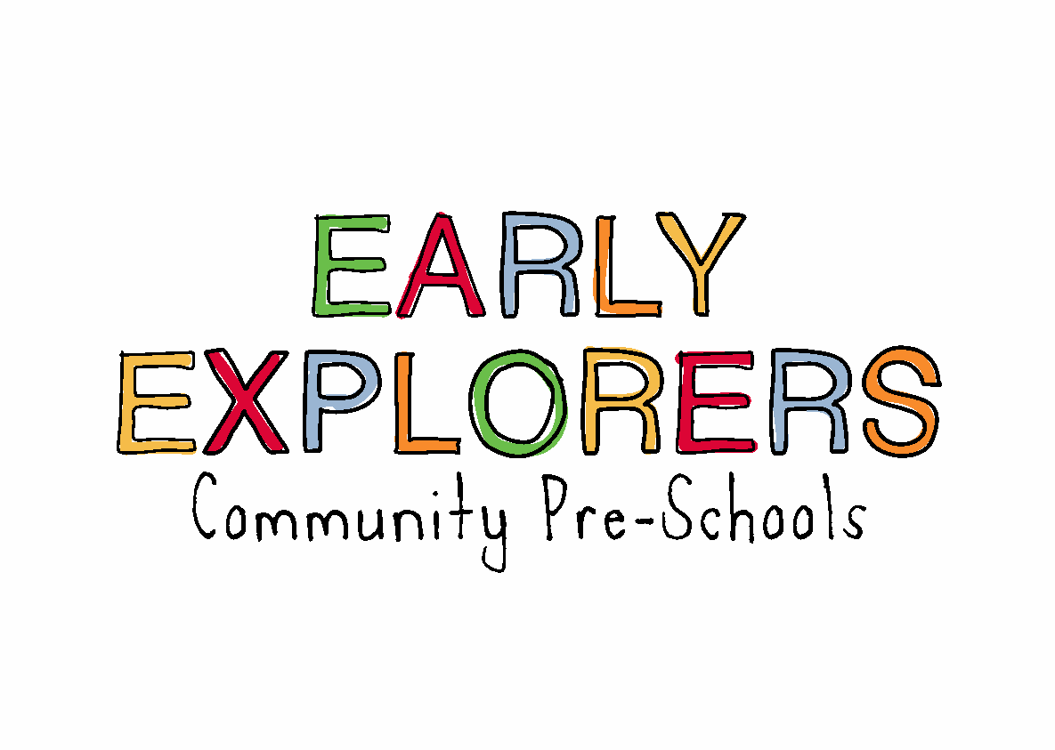
3.14 Oral health
The setting provides care for children and promotes health through promoting oral health and hygiene, encouraging healthy eating, healthy snacks and tooth brushing.
- Fresh drinking water is available at all times and easily accessible.
- Sugary drinks are not served.
- Children can bring their own bottles, we encourage water, however if they bring juice we will allow it due to the risk of dehydration for those who will only drink juice. Once their bottle is empty we will only re-fill with water.
- Only water and milk are served with morning and afternoon snacks. Water is served with lunch and tea
- Children are offered healthy nutritious snacks with the occasional treat eg. Birthday cakes.
- Parents are discouraged from sending in confectionary as a snack or treat.
- We teach children about looking after their teeth and the importance of good oral health.
Pacifiers/dummies
- Parents are advised to stop using dummies/pacifiers once their child is 12 months old.
- Dummies that are damaged are disposed of and parents are told that this has happened
Further guidance
Infant & Toddler Forum: Ten Steps for Healthy Toddlers www.infantandtoddlerforum.org/toddlers-to-preschool/healthy-eating/ten-steps-for-healthy-toddlers/

