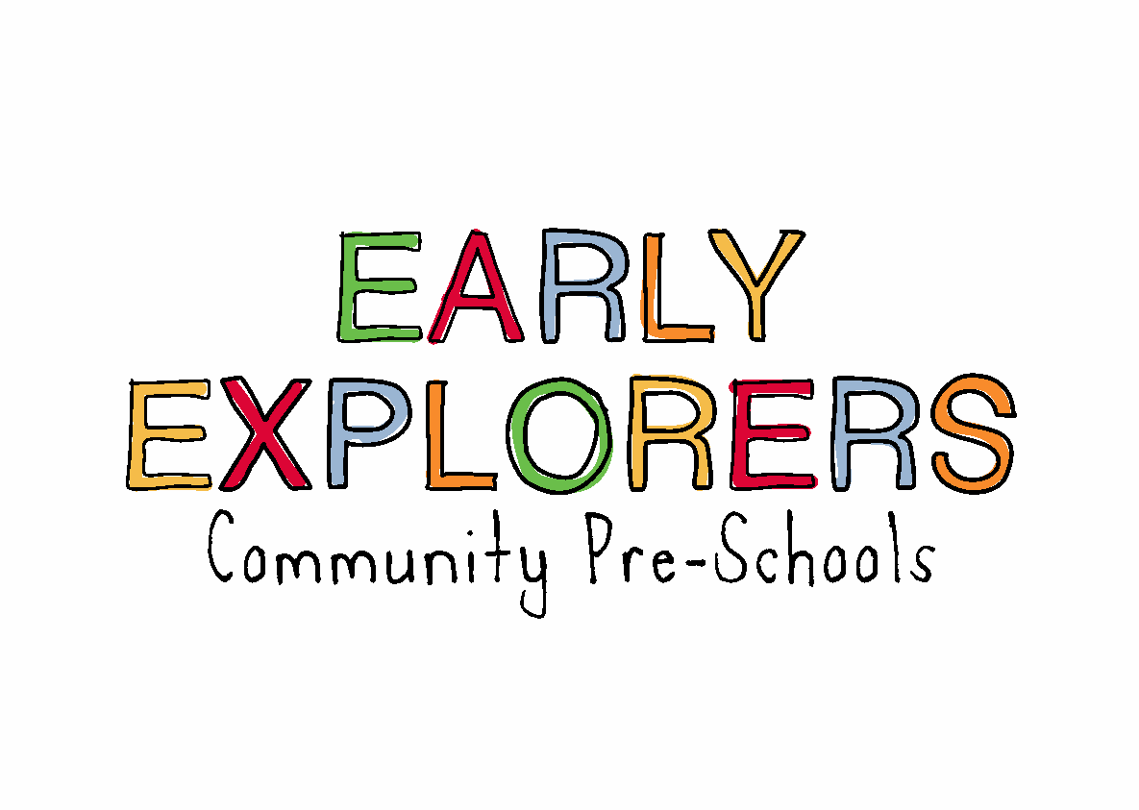
4.6 Working in partnership with parents
Aim
We actively promote partnership with parents and recognise the importance of working in partnership with other agencies to promote the well-being of children and their families. This includes signposting parents to support as appropriate.

Objectives
- We believe that parents are children’s first and most enduring educators and our practice aims to involve and consult parents on all aspects of their child’s well-being.
- We also recognise the important role parents must play in the day-to-day organisation of the provision.
- We consider parents views and expectations and will give the opportunity to be involved in the following ways:
- sharing information about their child’s needs, likes, achievements and interests
- settling in their child to the agreed plan according our settling in procedures
- taking part in children’s activities and outings
- contributing with ideas or resources as appropriate to enhance the curriculum of the setting
- taking part in early learning projects, sharing with practitioners knowledge and insights about their child’s learning
- contributing to assessment with information, photos and stories that illustrate how their child is learning within the home environment, taking part in day-to-day family activities
- taking part in discussion groups
- taking part in planning, preparing, or simply participating in social activities organised within the setting
- taking part in a parent forum to encourage the democratic participation of parents in discussions about the day-to-day organisation of the setting, consulting about new developments and other matters as they arise
- involvement in the review of policies and procedures
- Ofsted and setting contact details are displayed in the setting for parents who have a complaint that cannot be resolved with the setting manager in the first instance, or where a parent is concerned that the EYFS standards are not being maintained
Partnership and signposting to other agencies
- We are committed to ensuring effective partnership with other agencies including:
- local authority early years services about the EYFS, training and staff development
- local programmes regarding delivering children’s centres or the childcare element of children’s centres
- social welfare departments regarding children in need and children who need safeguarding or for whom a child protection plan is in place
- child development networks and health professionals to support children with disabilities and special needs
- local community organisations and other childcare providers
- Ofsted and setting contact details are made available to other agencies who have a complaint that cannot be resolved with the Setting Manager in the first instance, or where a parent is concerned that the EYFS welfare standards are not being maintained.
Legal references
Childcare Act 2006
Education Act 2011

