***Welcome back everyone, we are now in the final term of the school year and as always it's very busy. Transitions are planned to commence soon which will help the children move into their new environments smoothly. Your key workers will be in touch during July to have those final chats about moving on. We always have mixed emotions this time of year. We love to watch the children’s personalities develop as they grow and gain confidence to face the world but are also sad to see them fly the Pre-School nest or hop over to the next room.***

***Staff news - Please join us in welcoming 2 new staff members to the team. Emilia is level 2 qualified and has a particular passion for SEND, she will be working over at Bishops with some of our children who need a little extra support. Esme will be working across both settings as our new Early Years Apprentice, she did work experience with us a few years ago and was amazing with the children so we took the opportunity to snap her up when she showed an interest in pursuing Early Years as a career!***

*** Chicks News - We have had a little tidy up and move about in our garden to make better use of the space and ensure it is more user friendly for our younger chicks. Everyone is now able to enjoy the summer air safely! Inside we have a new carpet which gives a cosier feel to our newly decorated space. This is in preparation for September when our youngest chicks will be the ones using this room. Our favourite activities at the moment include our new tool bench and lots of ball play, we roll, kick, throw the ball to each other and into targets, all fun games which develop our motor skills. Amy is leaving to have her baby this week. We wish her much luck, love and happiness as she welcomes her little bundle into the world. We can’t wait to meet him! Alicia will be moving into the Chicks room to work with Abbie, along with Jess and Amy W covering some sessions.***

***Robins News -*** 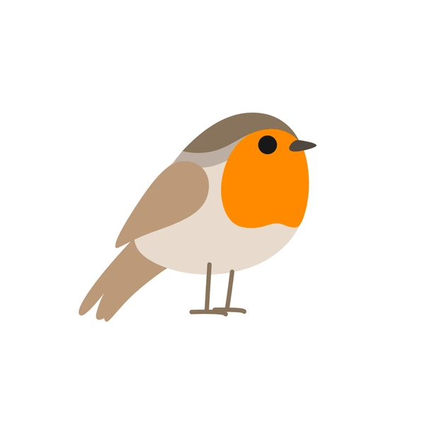

***Sand and water are still amongst our favourite activities, we particularly like catching sea creatures in our nets. We are also enjoying throwing balls at targets and are amazed that our veg is actually growing! We have some caterpillar pets at pre-school and are excited to watch them grow and change over the next couple of weeks. We like to play in the big cars. Bumping into each other makes us laugh! We also like to make giant structures in our construction area and will copy the handyman when he comes in, using our own tools and materials. Our favourite story is “the colour monster” it’s a story that allows us to recognise and express our emotions in a positive way.***



***Sparrow News***

**Role play with our friends is the thing we love the most in the Sparrows. One of our favourite games is to have a kitchen tea party. We use herbs to make drinks and potions. We also like to play with the babies and have a huge selection of items to bath, dress, feed, sleep and go travelling with our babies. A new interest is building towers. We do this on a large scale using big boxes then have fun jumping into them to knock it all over! We are learning the life cycle of a butterfly and are enjoying watching our caterpillars grow. It will be exciting to see them turn into butterflies that we can release in a few weeks time. Our children are extending their speaking and listening skills as they get ready for the next stage of their learning journey. During circle times we work together to establish Pre-School Rules and the children contribute to discussions taking turns to speak and listen.**

***HOWDEN SCHOOL TRANSITIONS - Howden Infants teachers will be visiting our Sparrows at Bishops Manor on Thursday 26th June. We will then visit them at the School on Tuesday 1st July. This visit is 9.30-11am. We will take the children who are at pre-school that day. If it is not your usual day and you would like to join us for this visit please meet us outside the school gates at 9.30am and collect your child from the school gates at 11am. If your child is attending a different school we have made separate arrangements for their new teachers to visit them.***

***GRADUATION DAY is Tuesday 15th July at 2pm. The afternoon will be a short concert followed by refreshments, photo opportunities and a chance to chat with the staff and say your final goodbyes. All Sparrow families are welcome to attend this event.***

***Fundraising***

***Thank you to everyone who supported our Summer Fayre. The weather wasn’t great which meant we had to simplify our plans last minute but we still managed to raise a healthy £240.***

***HOME LEARNING IDEAS***

**Outdoor fun - it's the perfect time of year to get in the garden. Why not use what you have to create a fun obstacle course with your child. You can use chairs and tables to go under and over, large cardboard boxes to make tunnels to travel through, plant pots to weave in and out of and even brushes and brooms to make little jumps. Pretend you’re riding a horse or a dinosaur as you gallop around the course. You could even dress up or make props to support the role play side of this game. Add a timer or introduce some counting and see who can get round the fastest.**

**When all the running round is finished you could turn your obstacle course into a cosy den. Have a picnic lunch, then grab a few blankets and cushions and cuddle up with your favourite books.**

**If you don’t have a garden why not visit a friend to play this game, or pack a bag and take a trip to the park or the marsh for a picnic and some storytime. Make the most of the beautiful weather!**

**GENERAL INFORMATION**

* **TOYS FROM HOME - we acknowledge some children may like to bring a toy or comfort item from home when they come to Pre-School, however please understand sometimes they do go missing. Children are encouraged to put their things in their box but unfortunately staff cannot monitor this.**
* **SUN CREAM - Please dress your child appropriately for the weather. Sun cream should be applied before their session, the all day cream is best however we can reapply at lunchtime if you supply a named bottle and have ticked consent on the permissions form on EYLOG.**
* **Please provide spare clothes. We advise naming everything, including drinks bottles, to avoid missing items.**

**Diary Dates**

**Tues 24th June - Sparrows Nursing Home visit**

**Thurs 26th - Howden Infants teacher visits the Sparrows at Bishops**

**Tues 1st July - Sparrows transition visit to Howden Infants**

**Tues 15th July - Sparrows Graduation 2pm at Bishops Manor**

**Fri 18th July - Pre-School closes**

**Mon 21st July - Fri 29th August - SUMMER HOLIDAY CLUB**

**Please note - Mon 1st and Tues 2nd September - CLOSED to all**

**Weds 3rd September - OPEN to all**

**We have an open door policy, you can call on us anytime during opening hours, please do not hesitate to make contact if there is anything you wish to discuss regarding your child. Thank you.**