Welcome everyone, we hope you all had a lovely Easter break.
Staff news - we’d like to introduce our new staff members! In the Chicks we have Hollie who has joined as support worker and Alicia and Michelle starting over the next couple of weeks as practitioners. Over at Bishops Manor Donna has joined the team as support worker and Demi will be joining the Robins as a practitioner in half term. In the Before and After School team we have Steph and Olivia who have already joined us and are enjoying their new roles. It's great to welcome new team members who are excited to join us on our Curiosity Approach journey.
Curiosity Approach News - Thank you for using the new entrance into Bishops Manor, we can already see the huge difference that offering outdoor play from arrival has on the children’s behaviour. Having the garden set and ready to go gives those who struggle to settle the space to regulate emotions at their own pace. It allows children to choose how to begin their day which builds confidence and decision making skills. When children release energy early through movement it improves their focus for quieter activities later in the day. As a result we are finding the children calmer, more engaged, sociable and curious. Conflicts and periods of restlessness have definitely reduced. Please feel free to use the grass area around the entrance, buggies and bikes can be brought in this way too. However please refrain from leaving them in the entrance.
Forest School - We are excited to be teaming up with Sally at In the Canopy for some forest school sessions over the summer term. Children will be taken to the In the Canopy base (next to the Ashes playing field) to spend time in a woodland environment, where they can explore, play and learn through very natural, hands-on experiences. These are for all age groups and will commence next month.

 Chicks News - It's amazing what difference a few changes can make. The team have had a little move around which has sparked off an interest in the role play kitchen area. Amy made a table cloth and some little curtains which they enjoy opening and closing. We’ve added a till and some note pads so they can take orders and charge for the lovely food they prepare! Outside the climbing equipment is hugely popular now it's been moved into the main garden. They also enjoy using the big cars to push and ride in and scooping and pouring in the water. The children are always fond of snuggly time and story time so we aim to develop this area during the term.


Sparrow and Robin News
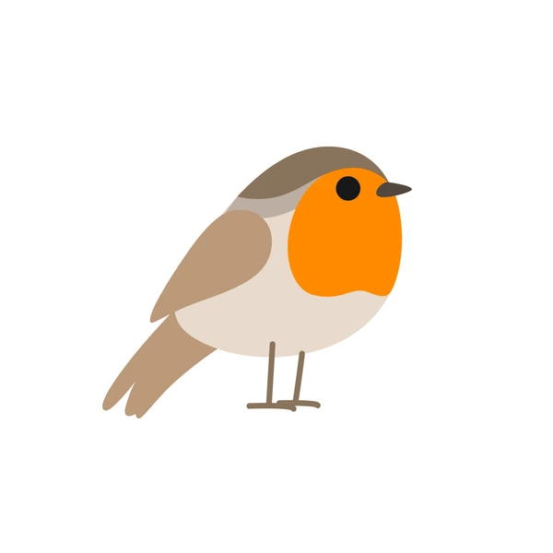
The children are happily exploring the new layout at Bishops. Inside they enjoy dressing up using the new headbands and jewellery and the well stocked craft room allows them lots of choice. Outdoors they use the pipes and gutters for rolling wheels and balls, they connect them for water play and send it off in all directions. In the sand pit they enjoy building volcanoes and making channels for the lava to travel down. We will be looking further at volcanos over the next few weeks along with beginning some planting in the garden. This will support us in learning about weight, measures and numbers.
We are using our short circle time sessions to develop listening skills with the Robins. We play fun games such as dough disco, whats missing? and whats that sound? The children really enjoy these activities.
We have introduced grab bags for circle time with the Sparrows, these contain fun games and activities for the staff to carry out in small groups. These activities incorporate all areas of learning and are aimed at introducing the children to a more adult-led activity which helps children prepare for school life.

Home learning - To help develop your child’s listening skills we encourage you to get outside! Listen to sounds, discover together, what is that? A bird in a tree, ducks flying over, the wind, an aeroplane. Is that a police car or a fire engine? Was that a dog barking? Next door is wheeling their bin out. Maybe when you listen it's just very quiet. It's good to be still and in the moment just listening together…..
To encourage your child to use more of their senses why not head out for a walk into nature. You could visit the Marsh or go further afield. What do you hear on your walk? Different bird noises, bees buzzing, plants and trees rustling. What can you smell? Maybe it's the cut grass and pollen, maybe it's the sea if you head that far! What can you see? Look on the ground, plants are beginning to grow, ladybirds and other bugs may be waking up and basking in the sun. What do things feel like? Look for sticks, bark, leaves, moss, long grass, pine cones etc, talk about the texture, allow your child to touch, you can even collect some and bring them into Pre-school for us all to enjoy. There’s so much to wonder about in the natural world!

Fundraising News - The Big Project - There is lots to do behind the scenes. Plans are being drawn up. Water and drainage systems, assessments, surveys, access routes all explored. Being on a historical site there are lots of things to consider and people to liaise with! We are hugely grateful to have the support of the Rotary Club who have taken a lead on the project and are helping us with every step. We will be having some small fundraising stalls at our graduation so make sure you bring a few pennies!

Wrap around care - Thank you so much for the huge increase in enquiries—we’re incredibly grateful for the continued support and trust in our setting. It really does mean a lot to us.
Unfortunately, due to limited spaces, we’re not able to accommodate every request at this time, and we completely understand how disappointing that may be.
As always, we will prioritise places for our pre-school children transitioning to big school, as well as siblings of children currently attending our setting. Any remaining places will then be offered on a first come, first served basis.
We do also operate a waiting list, so if you would like your child to be added, please get in touch with us and we’ll be happy to help.
We truly wish we could offer spaces to everyone and appreciate your understanding and patience. If anything changes, we will of course keep you updated.

What does my child need for pre-school?
Here’s a list of essentials to include in your child’s bag this term
- Sun hat, sun cream (named, to be kept at pre-school)
- Spare clothes, shoes, water bottle
- Nappies, wipes, comforter (if applicable)

Diary Dates
Mon 4th May - Bank Holiday - CLOSED
Fri 22nd May - Break up
Sat 23rd May - 11am-1pm Hannah’s SEND drop in coffee and play session at Bishops Manor
Tues 26th - Fri 29th May - Holiday Club
Mon 1st June - Summer 2 term starts
Tues 14th July - Sparrows Graduation 2pm - save the date!
Fri 17th July - Break up for Summer

As always, please do not hesitate to contact us if there is anything you wish to discuss regarding your child. Thank you.

