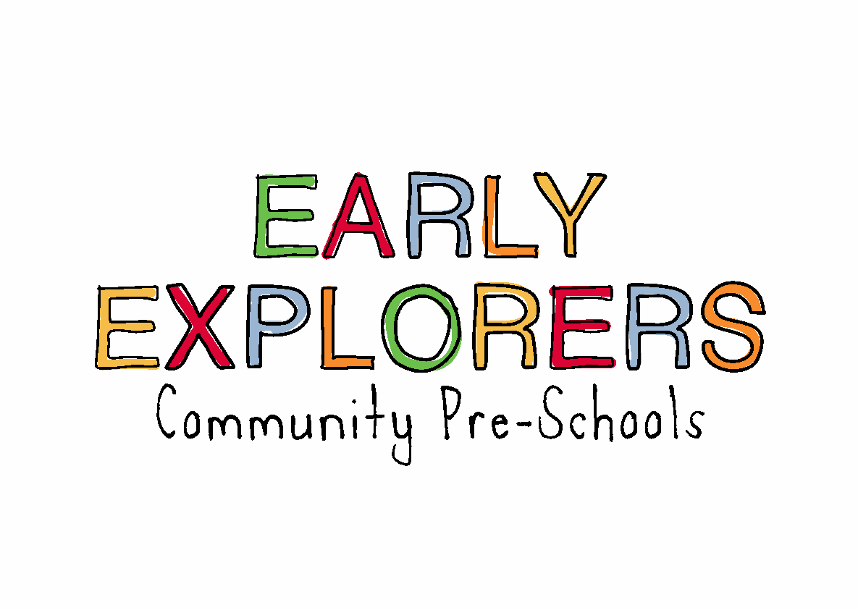

04. Health procedures

**04.6 Oral health**

Early Explorers Community Pre-Schools provide care for children and promotes health through promoting oral health and hygiene, encouraging healthy eating, healthy snacks and tooth brushing.

* Fresh drinking water is always available and easily accessible.
* Sugary drinks are not served.
* In partnership with parents/carers, babies are introduced to an open free-flowing cup at 6 months and from 12 months are discouraged from using a bottle.
* Only water and milk are served with snacks.
* Children are offered healthy nutritious snacks with no added sugar.
* Parents/carers are discouraged from sending in confectionary as a snack or treat.

**Pacifiers/dummies**

* Parents/carers are *advised* to stop using dummies/pacifiers once their child is 12 months old.
* Dummies that are damaged are disposed of and parents/carers are told that this has happened

**Further guidance**

Infant & Toddler Forum: Ten Steps for Healthy Toddlers [www.infantandtoddlerforum.org/toddlers-to-preschool/healthy-eating/ten-steps-for-healthy-toddlers/](http://www.infantandtoddlerforum.org/toddlers-to-preschool/healthy-eating/ten-steps-for-healthy-toddlers/)